Set an option to automatically track incoming Outlook email in CRM for Outlook:

When you use Microsoft Dynamics CRM for Outlook to track an email message, a copy of the email record is saved as an activity in Microsoft Dynamics CRM and synchronized with the Outlook record. More information: [Overview of tracking records in CRM for Outlook](https://www.microsoft.com/en-us/dynamics/crm-customer-center/overview-of-tracking-records-in-crm-for-outlook.aspx)

By default, tracking email is a manual process—you have to choose the **Track** button or the **Set Regarding** button for each email message you want to track. Manual tracking provides a way for you to keep your personal email separate from your customer email. As an alternative, you can set an option to track email messages automatically.

**Tip**

If you're using CRM Online and have installed Microsoft Dynamics CRM Online 2015 Update 1, you can use Exchange folder tracking as an alternate method for tracking messages automatically. With folder tracking, you can track messages directly from virtually any device. More information: [Track Outlook email by moving it to a tracked Exchange folder](https://www.microsoft.com/en-us/dynamics/crm-customer-center/track-outlook-email-by-moving-it-to-a-tracked-exchange-folder.aspx)

Automatically track email messages

1. In CRM for Outlook, on the **File** tab, choose **CRM**, and then choose **Options**.
2. In the **Set Personal Options** dialog box, on the **Email** tab, in the **Select how CRM for Outlook should integrate email with Microsoft Dynamics CRM** section, select the **Check incoming email in Outlook and determine whether an email should be linked and saved as a Microsoft Dynamics CRM record** option.
3. To specify whether to track all email messages or only certain types, in the **Select the email messages to track in Microsoft Dynamics CRM** section, in the **Track** list, select one of the following options:
   * **All email messages**. Tracks all email messages (sent and received) related to CRM email messages. If you select this option, CRM will track junk mail as well as business conversations, so choose this option carefully.
   * **Email messages in response to CRM email**. Only replies to or forwards of email messages that have already been tracked will be saved as email activities. This is the most common option.
   * **Email messages from CRM Leads, Contacts, and Accounts**. Tracks email messages only if they originate from someone with a Microsoft Dynamics CRM lead, contact, or account record.
   * **Email messages from Microsoft Dynamics CRM records that are email enabled**. Tracks email messages from all record types (including custom record types) that contain an email address field.

**Note**

Keep in mind that the more you use the same email address for tracking purposes, the less useful it becomes since it will be mapped to many records.

1. If you want to automatically create contract or lead records for tracked email messages, in the **Automatically create records in Microsoft Dynamics CRM** section, choose the **Create** check box, and then choose **Contacts** or **Leads** from the list. When this check box is selected, CRM for Outlook will try to match the email address of recipients to an email address in CRM. If it can't find a matching record, it will automatically create a contact or lead record.
2. **Note**

Contact and lead records won't be created if you don't have the appropriate security permissions. More information: [How security affects synchronization between CRM and Outlook](https://technet.microsoft.com/library/dn832097.aspx)

# Overview of tracking records in CRM for Outlook

You can use Microsoft Dynamics CRM for Outlook to track email messages, contacts, tasks, and appointments. When you track an email message, contact, task, or appointment record, a copy of that record is saved as an activity in Microsoft Dynamics CRM and synchronized with the Outlook record. You can then view and edit that record in CRM for Outlook or CRM. If you sync Outlook on your mobile device, you can also access these records on that device.

Tracking records in CRM for Outlook is a manual process. This gives you the ability to keep your personal Outlook records separate from your CRM records.

Tip

* If you want, you can set an option to track email automatically. More information: [Set an option to automatically track incoming Outlook email in CRM for Outlook](https://www.microsoft.com/en-us/dynamics/crm-customer-center/set-an-option-to-automatically-track-incoming-outlook-email-in-crm-for-outlook.aspx)
* If you're using CRM Online, have installed Microsoft Dynamics CRM Online 2015 Update 1, and your organization synchronizes records through server-side synchronization, you can track email messages through folder tracking. Folder tracking is a powerful and intuitive way to track email directly from virtually any device. More information: [Track Outlook email by moving it to a tracked Exchange folder](https://www.microsoft.com/en-us/dynamics/crm-customer-center/track-outlook-email-by-moving-it-to-a-tracked-exchange-folder.aspx)

On this page:

https://www.microsoft.com/en-us/dynamics/crm-customer-center/Down_Arrow.png[Using the Track button vs. the Set Regarding button](https://www.microsoft.com/en-us/dynamics/crm-customer-center/overview-of-tracking-records-in-crm-for-outlook.aspx#TrackVSSetRegarding)

https://www.microsoft.com/en-us/dynamics/crm-customer-center/Down_Arrow.png[Using the tracking pane](https://www.microsoft.com/en-us/dynamics/crm-customer-center/overview-of-tracking-records-in-crm-for-outlook.aspx#TrackingPane)

https://www.microsoft.com/en-us/dynamics/crm-customer-center/Down_Arrow.png[What can you do after you track a record?](https://www.microsoft.com/en-us/dynamics/crm-customer-center/overview-of-tracking-records-in-crm-for-outlook.aspx#AfterTracking)

https://www.microsoft.com/en-us/dynamics/crm-customer-center/Down_Arrow.png[Other things to know about tracking records](https://www.microsoft.com/en-us/dynamics/crm-customer-center/overview-of-tracking-records-in-crm-for-outlook.aspx#OtherThingsToKnow)

## Using the Track button vs. the Set Regarding button

To track a record in CRM for Outlook, you click or tap the **Track** button or the **Set Regarding** button for the record you want to track.

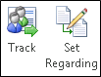

You can use either button to track a record, but it's almost always better to use the **Set Regarding** button. When you use the **Set Regarding** button, you can link an email message, appointment, or task to a specific CRM record such as an account or opportunity, or even a custom record type (entity). Some organizations also use the **Set Regarding** button to track projects.

## Using the tracking pane

When a record is tracked, a Microsoft Dynamics CRM pane (also known as the “tracking pane”) appears at the bottom of the record. This pane shows:

* Whether the item is tracked
* The regarding record, if set
* The name of the parent account for contacts, if set
* Links to CRM records for email recipients. This is very useful when you want to quickly access the CRM contact record of an email recipient or see other information stored in CRM.
* Related records, along with a symbol that identifies the record type in CRM
* Whether email addresses, names, or distribution lists in an email message are CRM records

For example, the following screen shot shows the tracking pane for a tracked task linked to the Adventure Works account:

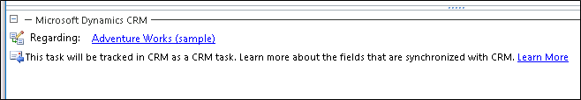

You can open the regarding record, parent record for a contact, or related records directly from the tracking pane. The tracking pane also includes an **Options** button that provides quick access to personal tracking options.

Note

If you track an email message without first expanding a distribution list, the tracking pane displays the name of the distribution list. To track the individual email addresses, expand the distribution list before you track the message.

## What can you do after you track a record?

After you track a record, you can use the buttons on the CRM for Outlook ribbon to do the following tasks.

|  |  |  |
| --- | --- | --- |
| **To do this task** | **Choose** | **Applies to** |
| Open the record directly in CRM | https://www.microsoft.com/en-us/dynamics/crm-customer-center/crm_ua_View_in_CRM_button.png | Email, appointments, contacts, and tasks |
| Add a connection between the record and any CRM record capable of tracking connections | https://www.microsoft.com/en-us/dynamics/crm-customer-center/crm_ua_.png | Email, appointments, contacts, and tasks |
| Convert the record into a CRM opportunity, lead, or case | https://www.microsoft.com/en-us/dynamics/crm-customer-center/crm_ua_Convert_to_button.png | Email, appointments, and tasks |
| Insert a CRM template | https://www.microsoft.com/en-us/dynamics/crm-customer-center/crm_ua_Insert_Template_button.png | Email |
| Insert a CRM Knowledge base article | https://www.microsoft.com/en-us/dynamics/crm-customer-center/crm_ua_Insert_Article_button.png | Email |
| Attach CRM sales literature | https://www.microsoft.com/en-us/dynamics/crm-customer-center/crm_ua_Attach_Sales_Literature_button.png | Email |

Tip

If these buttons aren't available, it may be that the record marked to be tracked isn't synchronized yet. This can happen if your organization uses server-side synchronization to synchronize email, appointments, contacts, and tasks, but the synchronization hasn't happened yet. If the **View in CRM** button is enabled, the record has been synchronized. You can also use the tracking pane (as described previously) to determine whether the record has been synchronized.

## Other things to know about tracking records

* **Using multiple computers.** You can use multiple computers to track items using CRM for Outlook. For example, you might use a desktop computer and a laptop. Only one computer can be the synchronizing computer, however. Changes or updates to synchronized records will not show up in CRM if the synchronizing computer is not connected to the CRM server. More information: [Set personal options that affect tracking and synchronization between CRM and Outlook or Exchange](https://www.microsoft.com/en-us/dynamics/crm-customer-center/set-personal-options-that-affect-tracking-and-synchronization-between-crm-and-outlook-or-exchange.aspx)
* **Choosing data to store locally.** The CRM data stored on your local computer is determined by online synchronization filters. You can edit, deactivate, or delete these filters. More information: [Choose the records to synchronize between CRM and Outlook or Exchange](https://www.microsoft.com/en-us/dynamics/crm-customer-center/choose-the-records-to-synchronize-between-crm-and-outlook-or-exchange.aspx)
* **Deleting tracked records.** When records are tracked, special rules apply when deleting records. More information: [Deleting records that have been tracked with CRM for Outlook](https://www.microsoft.com/en-us/dynamics/crm-customer-center/deleting-records-that-have-been-tracked-with-crm-for-outlook.aspx)
* **Delegating access.** If you've delegated access to your Outlook account, the delegate can track items on your behalf. These items won't synchronize with CRM until you connect to the CRM server. More information: [Allow someone else to manage your mail and calendar](http://go.microsoft.com/fwlink/p/?LinkId=201849)

# How field security affects synchronization between CRM and CRM for Outlook

**Dynamics CRM 2015**

2 out of 4 rated this helpful - [Rate this topic](https://technet.microsoft.com/library/dn832097.aspx#feedback)

Applies To: CRM 2015 on-prem, CRM Online

Securing a field in Microsoft Dynamics CRM with field level security can impact synchronization between CRM and Microsoft Dynamics CRM for Outlook. Consider the following scenario.

|  |
| --- |
| **noteNote** |
| We do not recommend securing a field in CRM when the field is set to sync. Best practice is to NOT secure any sync fields. If you do decide to secure sync fields, you’ll need to do the following:   1. Secure the field using field level security. More information: see “Set field level security” below. 2. Change the sync direction so that sync does not attempt to update or write the field during synchronization. More information: [Control field synchronization between CRM and Outlook or Exchange](https://technet.microsoft.com/en-us/library/dn832150.aspx) |

## [Scenario: Restrict users from changing Job Title](javascript:void(0))

The Contoso company wants to promote consistent data entry. While sales personnel are out in the field, it’s easy for them to create different data entries to describe the same thing. For example, the same job title could be entered as “Construction Manager”, “Foreman”, or “Site Manager”. To prevent this, the Job Title field is secured. This has consequences for synchronization.

### [Set field level security](javascript:void(0))

John, the CRM admin for Contoso, sets security on several fields.

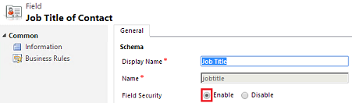

He did the following steps:

1. Go to **Settings** > **Customizations**. [(How do I get there?)](http://go.microsoft.com/fwlink/p/?LinkId=525636)
2. Choose **Customize the System**.
3. Expand **Entities** > **Contact**.
4. Choose **Fields** and select **jobtitle**. There are a lot of Contact fields so you’ll need to advance several pages.
5. Choose **Edit**.
6. For Field Security, choose **Enable** > **Save and Close**.
7. Choose **Publish All Customizations**.

John also secured the following Contact fields so they won’t appear in CRM: ftpsiteurl, governmentid

### [Create and configure a field security profile](javascript:void(0))

John creates a field security profile and assigns sales team members to the profile.

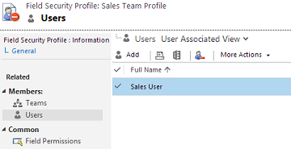

He did the following to create the field security profile:

1. Go to **Settings** > **Security**. [(How do I get there?)](http://go.microsoft.com/fwlink/p/?LinkId=525636)
2. Choose **Field Security Profiles**.
3. Create a profile. Choose **New** and enter a Name.
4. Choose **Save and Close**.
5. Choose the new profile > **Users** > **Add**
6. Select users and then choose **Select** > **Add**.

### [Set field permissions](javascript:void(0))

With a field security profile created and users added to the profile, John can now set permissions on the fields to match his organization’s requirements.

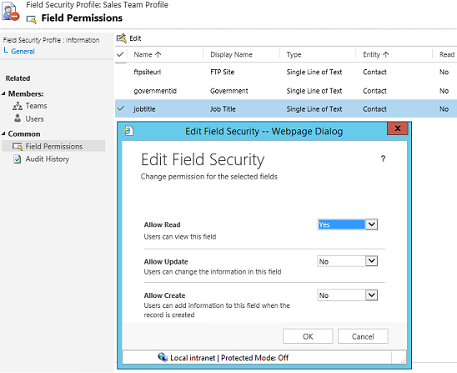

1. Go to **Settings** > **Security**. [(How do I get there?)](http://go.microsoft.com/fwlink/p/?LinkId=525636)
2. Choose **Field Security Profiles** > your profile.
3. Choose **Field Permissions** > the field to secure > **Edit**
4. Change the security settings to match your company’s requirements and then choose **OK** > **Save and Close**.

### [What the user sees](javascript:void(0))

Nancy, a salesperson at Contoso, uses Dynamics CRM for Outlook and creates a new contact and tracks it in CRM.

# Choose records to work with offline in CRM for Outlook

Choose a subset of Microsoft Dynamics CRM data to take with you when you go offline with Microsoft Dynamics CRM for Outlook by using offline synchronization filters. By default, these filters copy the appointments, contacts, and tasks records you own to your local drive. You might want to modify the filters to take a smaller subset of data with you or to synchronize particular records. For example, you might want to synchronize all reports since reports you don't own wouldn't normally be synchronized.

You can modify the existing filters or create new filters. You can also delete, deactivate, or activate filters. You can reset the filters every time you go offline.

Tip

To synchronize data and go online and offline more quickly, you can decrease the interval for automatic synchronization. More information: [Set personal options that affect tracking and synchronization between CRM and Outlook or Exchange](https://www.microsoft.com/en-us/dynamics/crm-customer-center/set-personal-options-that-affect-tracking-and-synchronization-between-crm-and-outlook-or-exchange.aspx)

## Create or modify offline synchronization filters

1. Do one of the following:
   * In the web app:
     + Choose the **Options** button in the upper-right corner of the window, and then choose **Options**.
     + In the **Set Personal Options** dialog box, choose the **Synchronize** tab.
   * In CRM for Outlook:
     + On the **File** menu, choose **CRM**.
     + Choose **Options**, and then in the **Set Personal Options** dialog box, choose the **Synchronize** tab.
2. Under **Manage your offline filters and take your information offline in Dynamics CRM for Outlook**, choose the **offline filters** link.

CRM displays the **Go Offline Settings** dialog box with the **User Filters** tab selected. You can use this tab to create or edit a filter, or to delete, activate, or deactivate a filter.

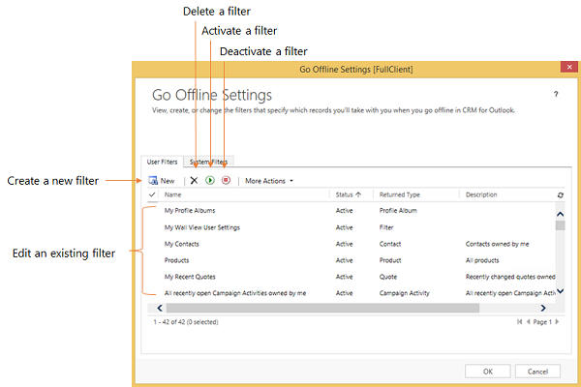

Note

If you're a system administrator, you can create or modify organization-wide filters (system filters) through the SDK. More information: [MSDN: Tell me more about system filters](https://msdn.microsoft.com/library/gg328205.aspx)

1. Do one of the following:
   * To open an existing filter, choose the filter.
   * To create a new filter, choose **New**.

## Creating or modifying filter criteria

You use a criteria row to create or modify criteria in an offline synchronization filter. Each criteria row contains three values: the field to use in the filter (for example, **City**), an operator (for example, **Equals** or **Contains**), and the value to filter on (for example, **WA**).

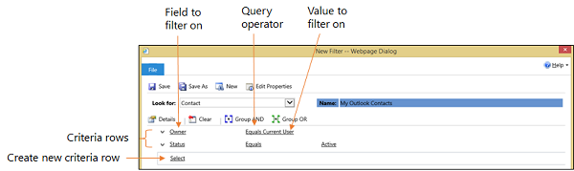

### Add a criteria row

1. In the **Look for** list, select a record type.
2. Point to **Select** in the criteria grid, and then select the field to filter on from the list.
3. Select an operator from the list.
4. Enter a value to filter on.

### Group rows of criteria

1. For each row you want to group, choose the **down arrow** to the left of the field name, and then choose **Select Row**.

To remove a row from a group, choose the **down arrow** to the left of the field name, and then choose **Delete**. To clear all rows from the criteria grid, choose **Clear**.

1. Choose **Group AND** or **Group OR**.

After creating a group, you can click the down arrow next to the **And** or **Or** to select from different options. You can select a group, ungroup the group, change a Group AND to a Group OR or vice versa, add a clause, or delete a group.

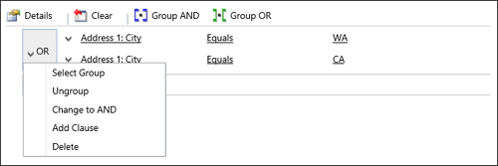

Applies To

CRM Online

CRM 2015 on-prem

CRM 2013 on-prem

See Also

[Work offline with CRM for Outlook](https://www.microsoft.com/en-us/dynamics/crm-customer-center/work-offline-with-crm-for-outlook.aspx)

[Example of going offline with CRM for Outlook](https://www.microsoft.com/en-us/dynamics/crm-customer-center/example-of-going-offline-with-crm-for-outlook.aspx)

[Choose the records to synchronize between CRM and Outlook or Exchange](https://www.microsoft.com/en-us/dynamics/crm-customer-center/choose-the-records-to-synchronize-between-crm-and-outlook-or-exchange.aspx)

[Synchronizing data with Outlook or Exchange FAQ](https://www.microsoft.com/en-us/dynamics/crm-customer-center/synchronizing-data-with-outlook-or-exchange-faq.aspx)

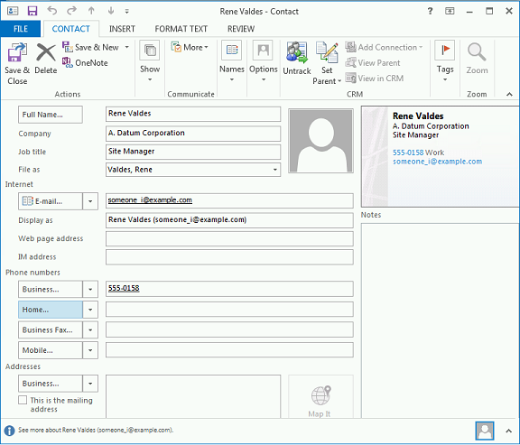

When Nancy synchronizes with CRM, she notices that the Job Title field is gone from the contact. This is because Nancy doesn’t have update rights for the Job Title field.

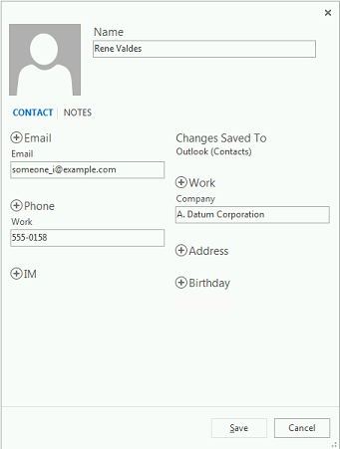

Nancy’s manager, with update rights to the Job Title field, fills in the field with the correct job title: Construction Manager.

Nancy synchronizes again with CRM and now the Job Title field is in the contact with the correct title.

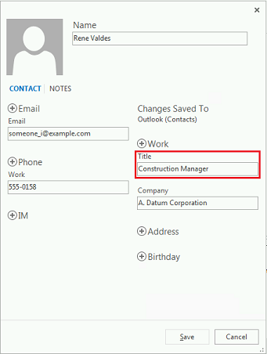

Set up CRM for Outlook:

<https://technet.microsoft.com/en-us/library/dn832060.aspx>

setup for outlook Vedio:

<https://www.youtube.com/watch?v=4lAUXAiLId4&feature=youtu.be>

Synchronizing data with Outlook or Exchange FAQ

<https://www.microsoft.com/en-us/dynamics/crm-customer-center/synchronizing-data-with-outlook-or-exchange-faq.aspx>

Control field synchronization between CRM and Outlook or Exchange

<https://technet.microsoft.com/library/dn832150.aspx>

Getting CRM Data into Outlook

<http://blogs.msdn.com/b/crm/archive/2011/04/14/getting-crm-data-into-outlook.aspx>

# Server Side Synchronization in Dynamics CRM Online

**[08](https://ssharmacrm.wordpress.com/2015/01/08/server-side-synchronization-in-dynamics-crm-online/)**[ThursdayJan 2015](https://ssharmacrm.wordpress.com/2015/01/08/server-side-synchronization-in-dynamics-crm-online/)

Posted by [Sandeep Sharma](https://ssharmacrm.wordpress.com/author/sharmasandeep82/) in [MS Dynamics CRM Online](https://ssharmacrm.wordpress.com/category/ms-dynamics-crm-online/)

**≈** [**Leave a comment**](https://ssharmacrm.wordpress.com/2015/01/08/server-side-synchronization-in-dynamics-crm-online/#respond)

**Tags**

[configure server-side synchronization in dynamics crm online](https://ssharmacrm.wordpress.com/tag/configure-server-side-synchronization-in-dynamics-crm-online/), [Server Side Synchronization CRM Online](https://ssharmacrm.wordpress.com/tag/server-side-synchronization-crm-online/), [Server side synchronization Dynamics CRM](https://ssharmacrm.wordpress.com/tag/server-side-synchronization-dynamics-crm/), [Server side synchronization in Dynamics CRM](https://ssharmacrm.wordpress.com/tag/server-side-synchronization-in-dynamics-crm/), [server side synchronization in dynamics crm online](https://ssharmacrm.wordpress.com/tag/server-side-synchronization-in-dynamics-crm-online/), [server-side syncronization](https://ssharmacrm.wordpress.com/tag/server-side-syncronization/)

Server side synchronization is a component in Microsoft Dynamics CRM that is used to integrate Microsoft Dynamics CRM with Exchange and POP3 or SMTP for sending/receiving an email. This component provides an alternative for using the CRM Email Router and the Outlook CRM client. With server side synchronization in Dynamics CRM, we can centrally managed mailboxes and profiles, configure email for users and queues.

CRM Online supports server-side synchronization with Exchange Online in the same tenant in Office 365 with Server to Server Authentication.

The following are the steps which requires to configure server-side synchronization

1. Create an email server profile: Email server profiles store settings that are used by server side synchronization in Dynamics CRM to connect to an email server and process email for the associated mailboxes.
   1. Go to Settings -> Email Configuration
   2. Click on Email Server Profiles
   3. Click on New -> Exchange Profile
   4. Specify the value for the required field (Fig. 1)

**Note:** When your CRM Online is integrated with Exchange Online through Office 365, an email server profile is created for you.

[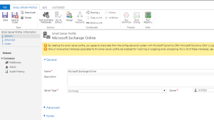](https://ssharmacrm.files.wordpress.com/2015/01/email-server-profile.png)

(Fig. 1)

1. Setup the Email Configuration Settings:
   1. Go to Settings -> Email Configuration
   2. Click on the “Email Configuration Settings”
   3. Set the “Process Email Using” and “Server Profile” (Fig. 2)

[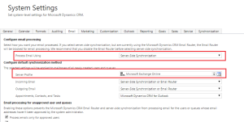](https://ssharmacrm.files.wordpress.com/2015/01/email-settings.png)

(Fig. 2)

1. Add mailboxes to an email server profile:
   1. Go to Settings -> Email Configuration
   2. Click on the Mailboxes
   3. Open the mailboxes that you want to associate with the email server profile
   4. Under the “Synchronization Method” in the “Server Profile” select the email server profile that you have created in the Step #1 (Fig. 3)
   5. Set the “Incoming Email” and “Outgoing Email” to “Email Router or Server-Side Synchronization” and click on Save
   6. Now click on the “Approve Email” and then click on the “Test and Enable Mailbox”

[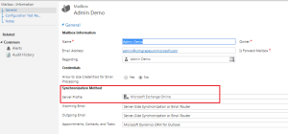](https://ssharmacrm.files.wordpress.com/2015/01/mailbox.png)

Switching from an Email Router to Server-Side Sync in Dynamics CRM 2013http://www.powerobjects.com/2014/07/22/switching-email-router-server-side-sync-dynamics-crm-2013/

<http://blog.webfortis.com/three-paths-of-email-routing-in-crm.-first-path-server-side-syncronization>

Set up email processing through server-side synchronization

<http://www.microsoft.com/en-us/dynamics/crm-customer-center/set-up-email-processing-through-server-side-synchronization.aspx>

# Server-side synchronization

**Dynamics CRM 2015**

1 out of 4 rated this helpful - [Rate this topic](https://technet.microsoft.com/en-us/library/dn832121.aspx#feedback)

Applies To: CRM 2015 on-prem, CRM Online

Server-side synchronization is the preferred option for organizations with users who run Microsoft Dynamics CRM in a web browser or on a mobile device, such as a tablet or smartphone. Server-side synchronization provides direct Microsoft Dynamics CRM-to-email server synchronization. When you use Exchange, this includes bi-directional synchronization of email, contacts, tasks, and appointments. The data synchronized for each user can be controlled by using synchronization filters that are available from the **Synchronization** tab in the Microsoft Dynamics CRM user options dialog.

If you use a POP3 email server, the data that is synchronized includes email only.

Using server-side synchronization makes messaging data available to a web browser, tablet, or smartphone that is running Microsoft Dynamics CRM.

For more information about server-side synchronization, see [Set up server-side synchronization of email, appointments, contacts, and tasks](https://technet.microsoft.com/en-us/library/dn531109.aspx).

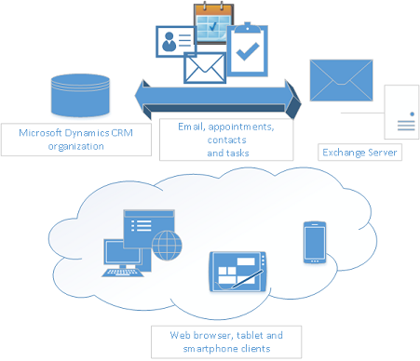

|  |
| --- |
| **noteNote** |
| A Microsoft Dynamics CRM user can only map to a single Exchange or POP3 mailbox. Similarly, an Exchange or POP3 mailbox can only be mapped to a single Microsoft Dynamics CRM user. When Microsoft Dynamics CRM detects that an Exchange or POP3 mailbox has already been mapped to a Microsoft Dynamics CRM user, a dialog box is displayed to present a choice to the user whether to map the Microsoft Dynamics CRM user to the Exchange mailbox. When the user selects yes, it breaks the previous Microsoft Dynamics CRM user to Exchange mailbox mapping and subsequently the synchronization that would occur between the Microsoft Dynamics CRM user and the Exchange mailbox. |

### [Server-side synchronization frequency](javascript:void(0))

When synchronization by using server-side synchronization occurs, the process is dynamic and unique to each user’s mailbox. Normally, synchronization occurs every 15 minutes. However, the synchronization frequency is determined based on the activity and load of the user’s mailbox. So, if a user’s mailbox is idle for a long period of time, the synchronization frequency will automatically increase, and may increase by hours. Notice that the synchronization frequency will also change based on the load and network connectivity of the user’s environment.

## [Features available with server-side synchronization in both Microsoft Dynamics CRM Online and Microsoft Dynamics CRM (on-premises)](javascript:void(0))

Some features offered by server-side synchronization include the following:

* **Efficient resource utilization.** Server-side synchronization provides integrated mailbox management. You can disable inactive mailboxes that have permanent errors. It prevents resource hogging by applying an upper limit on the allocated capacity and time-out requests.
* **Connection throttling.** Server-side synchronization provides a way to control the number of parallel connections opened against an email server to prevent overloading the mail server.
* **Data migration.** Server-side synchronization supports migrating configuration data from Email Router to server-side synchronization by using the migration wizard. More information: [Migrate settings from the Email Router to server-side synchronization](https://technet.microsoft.com/en-us/library/dn832114.aspx), [Merge email server profiles for migration](https://technet.microsoft.com/en-us/library/dn531068.aspx).
* **Service isolation.** Server-side synchronization has separate queue-management and configuration settings for asynchronous operations, outgoing activities, and mailboxes. It is based off asynchronous service architecture and may share the same process. In all cases, it manages server resources while maintaining isolation with the asynchronous service.
* **Error reporting for users and administrators.** Server-side synchronization supports logging and reporting of errors specific to an email or one or more mailboxes. More information: [Error logging for server-side synchronization](https://technet.microsoft.com/en-us/library/dn531049.aspx).

|  |
| --- |
| **noteNote** |
| * In Microsoft Dynamics CRM 2013 and Microsoft Dynamics CRM 2015, you can synchronize emails using Dynamics CRM for Outlook or server-side synchronization. If server-side synchronization is selected, the synchronization does not require running Dynamics CRM for Outlook. You will, however, still need Dynamics CRM for Outlook to promote an item from Outlook. |

## [Features available with server-side synchronization in Microsoft Dynamics CRM (on-premises)](javascript:void(0))

Some features offered by server-side synchronization with Microsoft Dynamics CRM (on-premises) include the following:

* **New performance counters.** New performance counters have been added to Activity and mailbox queue for Asynchronous service and server-side synchronization. More information: [Download: Microsoft Dynamics CRM Async Service counters](http://go.microsoft.com/fwlink/p/?LinkId=328729), [Download: Microsoft Dynamics CRM Server-Side Synchronization counters](http://go.microsoft.com/fwlink/p/?LinkId=328730).
* **Server role deployment.** Server-side synchronization leverages the Asynchronous Service server role on the Microsoft Dynamics CRM server.